Tubby or Not Tubby……
That is the Question
As the season of good will approaches we can all appreciate the over whelming urge to over indulge. We avoid the scales and promise ourselves that the diet will start in January. Surely one more mince pie couldn’t hurt!

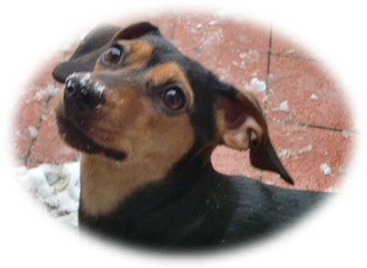
With all the yummy treats available at this time of year it is no surprise we tend to pile on the pounds but does the same apply to our pets? With long dark cold winter nights many dogs aren’t getting off the lead for a good run around and long walks are limited to weekends. When the weather turns bad even the most adventurous of our feline friends choose to sit by the fire rather than brace the cold in search of a mouse.

It has been reported that in the UK over 50% of companion animals including horses are currently obese or overweight. This is a shocking statistic and not something that should be taken lightly. Part of the problem with obesity is the stigma that surrounds it. If I walked a very thin dog down the street I would be met with judgmental looks and muttered comments of disapproval. A fat dog however would harley get a second glance. In fact lots of caring and conscientious owners don’t realize their dogs and cats are fat. Body condition scoring is a good way to tell wether your pet could drop a kilo or two. The ribs should be easily felt and a waist should be present when you look at you pet from above.


We are all aware that being under or overweight is not healthy. There is however increasing evidence that for our companion animals being a little underweight is far healthier in the long term than being overweight. It has been shown that lean Labradors live up to two years longer than obese dogs.

Its not just weight gain we need to watch out for this festive season lots of Christmas goodies are poisonous to our pets. We all know chocolate is dangerous to dogs and cats but at this time of year it is far more available, from hanging chocolates on Christmas trees to advent calendars that can fall and be quickly gobbled up. Products containing raisins are poisonous to dogs this includes mince pies, Christmas cakes and puddings.

Also remember to dispose of turkey carcasses appropriately as a dog or even cat can end up requiring a big surgical operation if the bones are eaten.

Our companion animals today live luxurious lives where they need to spend no energy at all in finding food. It is therefore our responsibility to limit their intake of calories, just as it is our responsibility to ensure they are exercised and not fed poisonous foods.

